Subject | VHF/UHF/MW Contest Rules
Society | IARU Region 1 | Country: | N/A
Committee: | C5 | Paper number: | NS20_C5_23
Author: | Alessandro Carletti, IV3KKW Contest WG Chairman

Abstract :
During the last Vienna Interim Meeting 2019 on C5 session it has been presented the VIE19 C5-006 by MRASZ.

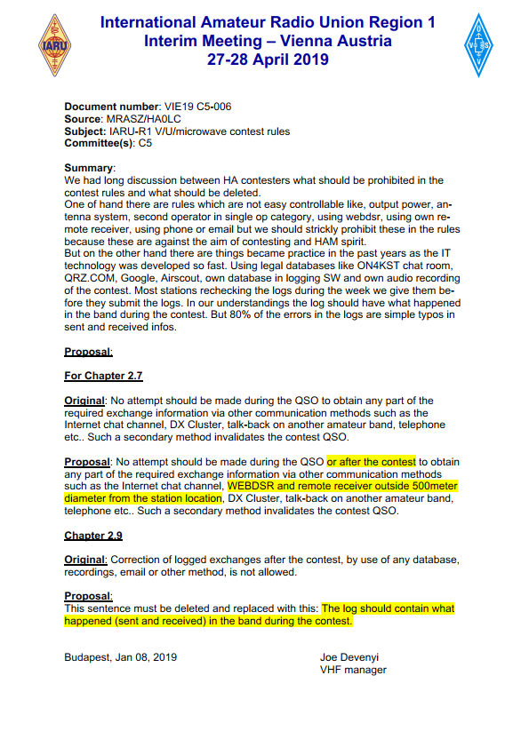

After a discussion with the representatives in Vienna, it has been decided with to carry this document to the Contest WG, with the guidance of C5 (VIE19_C5_Rec_10).

Proposal :
The C5 Contest Working Group after discussing it, it came to the following decision:

- to amend the VHF Handbook Paragraph 2.7 with the following proposal:

Original version:
No attempt should be made during the QSO to obtain any part of the
required exchange information via other communication methods such as the
Internet chat channel, DX Cluster, talk-back on another amateur band, telephone
etc..
Such a secondary method invalidates the contest QSO.

Proposed Version:
No attempt should be made during the QSO or after the contest to obtain
any part of the required exchange information via other communication methods
such as the Internet chat channel, WEBDSR and remote receiver outside 500 meters
diameter from the station location, DX Cluster, talk-back on another amateur band,
telephone etc..
Such a secondary method invalidates the contest QSO.

- to amend the VHF Handbook Paragraph 2.9 with the following :

Original version:
Correction of logged exchanges after the contest, by use of any database,
recordings, email or other method, is not allowed.

Proposed Version:
Correction of logged exchanges after the contest, by use of any database, recordings, email or other method, is not allowed. The log should contain what happened (sent and received) in the band during the contest.

